**Cybersecurity – Code generation**

**Johan Nel – Gr 10-5**

Hoërskool secunda

IT PAT

# Table of Contents

Table of Contents 1

1. Define the task 2

• In short 2

• Topic 2

• Purpose/Needs 2

• Possible Solution 3

• Scope 3

2. User requirements 3

• What will the system do? 3

• How will the system be used? 3

• Who will use the system? 3

→ Learner 5

→ Teacher 5

→ Network Administrator 5

3. Description of flow diagram 6

4. GUI Design 7

• Form 1 - Panel 2: Creating a new account 7

→ Input 8

→ Processing 8

→ Output 9

→ Other 9

→ Validation 9

→ Algorithms to illustrate how data will be processed 11

• Form 1 - Panel 1: Logging into an existing account 13

• Form 2 – Panel 1: Select multifactor authentication type 14

• Form 2 – Panel 2: One-Time Pin 15

• Form 2 – Panel 3: Text Captcha 16

• Form 3 – Panel 1: Used by Learners 17

• Form 3 – Panel 2: Used by Teachers 18

• Form 3 – Panel 3: Displayed to Admins 19

5. Data dictionary 20

6. Extra information 20

• Premade users in the Database 20

• Captcha generator links 20

• Enable the Database in the Delphi program 21

**Please note:** Most of this task up to Form 2 has been done before the PAT has been explained – therefore, some information might be extra or not needed. Also, even though an example of a program for the school was used in class, I came up with that idea when I started with the PAT on the 22nd of September. The example was used on the 30th of September.

# Define the task

## In short

I will be designing and coding a program for the school. This program will generate a username when the user registers a new account. It will allow Learners, Teachers, and Admins to log in. When the username and password is correct, they should verify their identity by using the computer-generated captcha or one time pin.

Unlike your usual OTP where you should just retype the message that has been sent to your phone; this One Time Pin will use a generated phrase that the user should decode/decipher. They will turn the phrase into a number.

With the Captcha, a couple of characters will be generated. These characters will be mixed with some lines. These characters cannot be read by computers, but they can be read by humans. You should just retype the generated characters correctly to continue.

The admin can bypass multifactor authentication if he/she chooses to do so.

After the user entered the captcha/OTP correctly, they can use the program that is specifically made for them:

* The learner will be able to calculate their average for a subject using weights.
* The teacher will be able to calculate a class average after they entered averages of several learners.
* The admin will be able to load log files into a rich edit.

## Topic

The topic for this PAT is code generation, therefore I will use Delphi to generate codes such as Usernames, Captchas and One-Time-Pins. I must create a program that uses the input of the user, to create a username. The program should also be able to determine the strength of the password. When the user logs in, the program should allow the user to enter the automatically generated captcha code to verify that they are human, and after that they should be taken to the last form (Form 3) where they can use the program that is designed for their user type.

## Purpose/Needs

My program will be used to create usernames, test password strength, and allow users to log into their account. It could be used by a school as a login portal for learners and teachers. Admins will also be able to use it to test the system and make sure everything works as expected.

## Possible Solution

My program will use algorithms to create usernames. It will use if-statements to test the strength of the password, and it will use for-loops to generate captcha codes and One-Time-Pins.

These forms will include

* One to create a new user profile/account or log in to an existing user profile/account.
* One to check if the user is a human. This form will contain the captcha code and OTP.
* The last form will be a program that is specifically designed for the user.

## Scope

My program will be able to use a database to store and save the username and password. Users will not be able to edit their profiles once an account is created. Passwords and all information about the user will not be encrypted (meaning that anyone that can open the database, can see this information). The program will not be able to send information to external devices such as phones to verify the identity of the user – It is too difficult to implement APIs into Delphi 2010. It is easier when using a newer version of Delphi, or another programming language.

# User requirements

## What will the system do?

This system will allow users to create an account if they have not done so before. When a new account is created, the username is generated automatically by the computer. When their account has been created, and the database has recorded it, the user will be able to log in.

When the user logs in and their information is correct, they will be required to verify their identity by using an OTP, or to verify that they are human by using the built-in captcha system.

After successful login and multifactor authentication, the user will be able to use the program designed for their user type.

## How will the system be used?

The system will use a database system to register and verify users. The computer will then generate codes (OTP and Captcha codes), to verify the user. After successful login and multifactor authentication, the user will be able to use the program designed for their user type.

## Who will use the system?

The system will be used by the learners, teacher, and network administrators of the school. Their roles are described below.

### Learner

This user will be a learner of the school.

|  |  |
| --- | --- |
|  | **Description** |
| Role | This user will use this program to log in using an automatically generated username and a custom password. When logged in, they will be able to use a program to calculate their average for a subject by entering their marks and the weight each task counts. |
| Activity | The learner will be able to:   * Create an account * Log in * Use the multifactor authentication to verify that they are human/to verify their identity * Be able to calculate their average for a subject by entering their marks for tasks, and the weight of each task. |
| Limitations | The learner will not be able to access log files. They will not be able to save the average they calculate (as this isn’t the primary focus of the PAT). |

### Teacher

This user will be one of the teachers at the school.

|  |  |
| --- | --- |
|  | **Description** |
| Role | This user will use this program to log in using an automatically generated username and a custom password. They will be able to read marks into the computer to calculate a class/grade average. |
| Activity | The teacher will be able to:   * Create an account (the teacher should select the teacher option) * Log in * Use the multifactor authentication to verify that they are human/to verify their identity. * Read marks into the computer to calculate the class average. |
| Limitations | The teacher’s limitations are quite like those of the learner. They won’t be able to access log files. They will not be able to save the class average or the information of learners (as this isn’t the primary focus of the PAT). |

### Network Administrator

The Network Administrator (or Admin) is someone that has computer knowledge. They can control the whole system and see what goes wrong using log files.

|  |  |
| --- | --- |
|  | **Description** |
| Role | The admin will be able to log in with their username and password. When they do so, they get access to admin features. They debug and test the program using the log files that the program will create, to make sure everything works as expected. They can also bypass multifactor authentication. |
| Activity | The admin will be able to:   * Create an account for another user * Log in * Bypass multifactor authentication * They can load Log files to debug the program and make sure everything works as expected. * They will be able to access the Learner’s panel and teacher’s panel. |
| Limitations | Admins don’t really have any limitations. Their limitations are defined by the limitations mentioned in the scope of the project. |

# Description of flow diagram

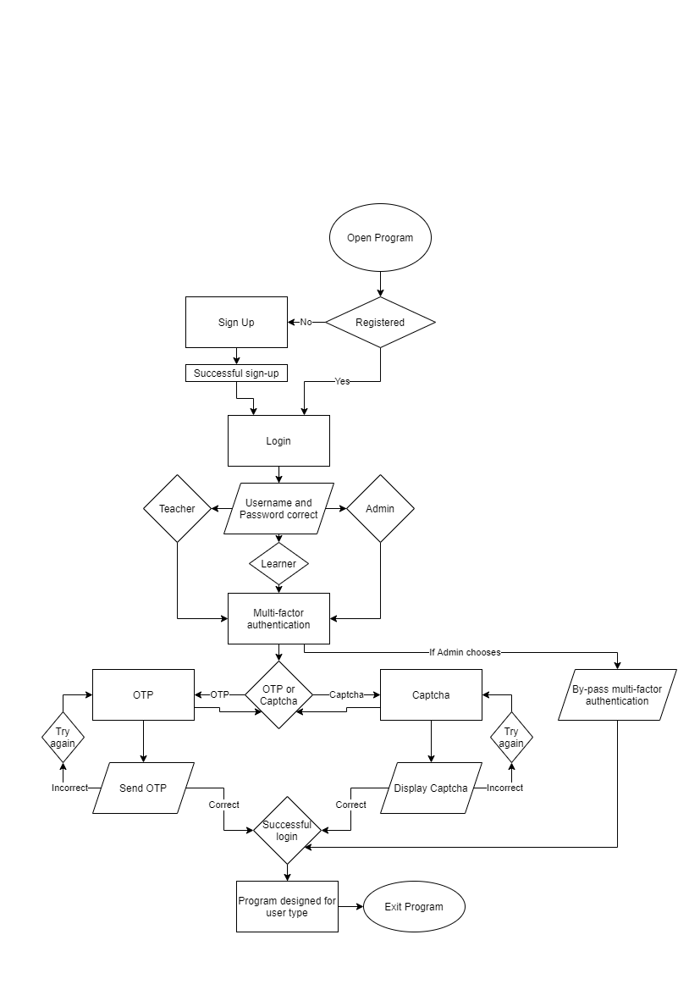

When the program is opened, the user will be on the Log In screen.

If the user isn’t registered, they will be taken to the Account Creation screen, so that they can register. When they have registered successfully, they will be taken back to the Log In screen where they can log in.

If the user is registered, they can log in by typing in their username and password. When the user logs in, the computer will recognise if the user is an Admin, Teacher or Learner.

If both the Username and Password is correct, the user will be taken to the multifactor authentication screen where they can select if they want to be verified by OTP, or Captcha. If the user is an admin, the computer will ask them if they want to skip multifactor authentication.

If the user selects OTP, the OTP will be displayed to the user. If the user enters the OTP correctly, they will be taken to the last form where they will be able to use the program designed for their user type; otherwise, the user can try again.

If the user selects Captcha, the Captcha will be displayed to the user. If the user re-enters the Captcha correctly, they will be taken to the last form where the user will be able to use the program designed for their user type; otherwise, the user can try again.

On the last form, where the user can use the program designed for their user type, the user can close the program. They can also close the program on the log in screen.

# GUI Design

**Note:** Only Form 1 has IPO and algorithms tables. I do not get marks for IPO tables algorithms. The IPO tables and algorithms for form 1 has not been updated since the PAT explanation. They were done before the explanation of the PAT.

## Form 1 - Panel 2: Creating a new account

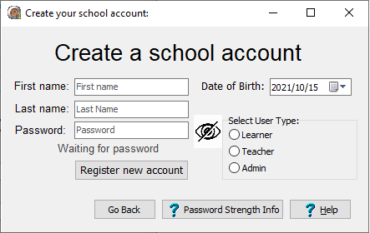

### Input

|  |  |  |  |  |
| --- | --- | --- | --- | --- |
| **Input** | | | | |
| **Variable Name** | **Source** | **Data type** | **Format** | **GUI component** |
| * sFirstName * sSurname * sEnterPW/   sTPPassword | User enters the information using the keyboard | String | Length of variables:   * sFirstName = 20 * sSurname = 20 * sPassword = 30 | Edit Box |
| dBirthDate | User uses the mouse to select a date using a date/time picker | TDate | Short date: yyyy/mm/dd | DateTime picker |
| cUserType | User selects whether they are a Learner/ Teacher/ Admin using the mouse and radio group | Char | Length = 1 with default value of ‘L’ (learner)  L: Learner  T: Teacher  A: Admin | Radio group box |

### Processing

|  |  |  |
| --- | --- | --- |
| **Processing** | | |
| **Variable name** | **Data type** | **Description** |
| sUsername | String | The username is used to identify the user when logging in. The computer generates it automatically when you register. |
| Password character counters:   * iHigh * iLow * iSpecial * iNumber * iSpace | Integer | When the user enters sEnterPW, the computer uses a for-loop to determine the number of each type of character that is present. |
| sStrength | String | Using the variables above, if-statements determine the strength of the password. Only passwords with “Medium” and “High” strength can be used. |
| bEnterPW | Boolean | This variable will be true if the password has strength “Medium” or “High”, and false if it has strength “Low”. The program will check if this variable is true before the user can register an account. |

### Output

|  |  |  |
| --- | --- | --- |
| **Output** | | |
| **Output** | **Format** | **Output component** |
| Successful registration: Username and Password | Welcome <sFirstName>! The Username you will use to log in is: <sUsername> with Password as: <sEnterPW> | Dialog box |
| Password strength | Password strength: <sStrength> | Label |
| Password error (contains space, or “Low” strength) | Your password needs to be "Medium" or "High" quality! The password also can't contain a space | Dialog box |

### 

### Other

|  |  |
| --- | --- |
| **Other components** | |
| **Component** | **Description** |
| Bitmap buttons | The “help” buttons are bitmap buttons with kind ‘Help’. They give more information about how the program works, and how to use the program when it is clicked by the user |
| Panel | This ‘form’ is made on a panel that can be visible when needed and made invisible when the user successfully created an account. The panel can also be moved out of the way |
| Labels | Labels will be used for the heading ‘Create a school account’. It will also be used to mark the edit boxes clearly, so that the user can easily understand what to enter where. |
| Image | The image component is used to show if the password is visible or not. The user can click the image to either make the password visible, or invisible – It will show the *current* state of the password. Meaning if the password isn’t visible, it will look like this: |

### Validation

|  |  |
| --- | --- |
| **Validation – Has the information been entered?** | |
| Error will be displayed with a Dialog Box | |
| **What will be validated** | **Error** |
| I will test if the user entered a First Name | You need to enter a First Name to register a new account! |
| I will test if the user entered a Password | You need to enter a Password to register a new account!  Please remember that your password should be either “Medium” or “High” strength. |
| I will test if the user entered a Last Name / Surname | You need to enter a Last Name to register a new account! |
| I will test if the Birth Date entered is a future date. If it is a future date, the error message will be displayed | You need to enter a past date to register a new account! |
| I will test if the user selected an option from the radio group. | You need to select which type of user you are (Learner/Teacher/Admin) to register a new account! |

|  |  |
| --- | --- |
| **Validation – Is the information too long?** | |
| Error will be displayed with a dialog box | |
| **What will be validated** | **Error** |
| I will test if the length of the First Name is longer than 20 characters | Your First Name cannot be longer than 20 characters! Please make it shorter to register an account. |
| I will test if the length of the Last Name is longer than 20 characters | Your Last Name cannot be longer than 20 characters! Please make it shorter to register an account. |
| I will test if the length of the Password is more than 30 characters | Your Password cannot be longer than 30 characters! Please make it shorter to register an account.  Please remember that your password should be either “Medium” or “High” strength. |

|  |  |
| --- | --- |
| **Validation – Is the information too short?** | |
| Error will be displayed with a dialog box | |
| **What will be validated** | **Error** |
| I will test if the length of the First Name is shorter than 3 characters | Your First Name cannot be shorter than 3 characters! Please make it longer to register an account. |
| I will test if the length of the Last Name is shorter than 3 characters | Your Last Name cannot be shorter than 3 characters! Please make it longer to register an account. |

|  |  |
| --- | --- |
| **Validation – Is the password valid?** | |
| Error will be displayed using a label underneath the edit box. | |
| **What will be validated** | **Error** |
| I will test if the Password contains a space | You may not enter a space |
| I will test if a Password is entered | Waiting for Password |
| I will test if the strength of the Password is medium or high using predetermined characteristics. If the password’s strength Is “Low”, the error message will be displayed | Your password needs to be "Medium" or "High" strength!  Please make sure it meets the given characteristics. To find the characteristics, you can click on the "Password Strength Info" button. – Error will be displayed with dialog box. |

### Algorithms to illustrate how data will be processed

**Creating the Username:**

The aim of this algorithm is to generate a username using the information the user entered. This username will be used to log in.

**Testing the strength of the password:**

The aim of this algorithm is to test the strength of the password. If the password isn’t the correct strength, you will not be able to register an account

## Form 1 - Panel 1: Logging into an existing account

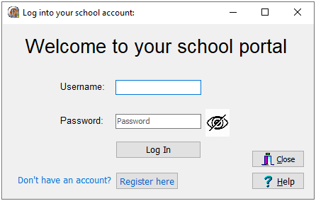

|  |  |  |  |  |
| --- | --- | --- | --- | --- |
| **Input** | | | | |
| **Variable Name** | **Source** | **Data type** | **Format** | **GUI component** |
| sEnterUN | User enters the Username using the keyboard | String | Length of variable:  sEnterUN = 11 | Edit Box |
| sPassword | User enters the Password using the keybaord | String | Max Length of variable:  sPassword = 30 | Edit Box |
| cByPass | The admin answers y/n using the keyboard | Char | Length:  cByPass = 1  cByPass can only be a Y or N | Input Box |

|  |  |
| --- | --- |
| **Components** | |
| **Component** | **Description** |
| Label | A Label will be used for the heading ‘Welcome to your school portal’. It will also be used to show the user what they should enter in which edit boxes. |
| Edit Boxes | The user should enter their computer-generated Username in the username edit box. If it isn’t found in the database, an error message will be displayed.  The user should also enter their Password in the password edit box. If the password doesn’t match the username, an error message will be displayed. |
| Image | The image component is used to show if the password is visible or not. The user can click the image to either make the password visible, or invisible – It will show the *current* state of the password. Meaning if the password isn’t visible, it will look like this: |
| Button – Log In | The Log In button will be pressed when the user entered both the username and password. If both are correct, they will be taken to the next form, otherwise an error message will be displayed. |
| Button – Register here | The Register here button will be pressed if the user needs to create a new account, because they don’t have one already. |
| Bitmap button - Help | The “help” button is a bitmap button with kind ‘Help’. It gives us more information about how the program works, and how to use the program when it is clicked by the user |
| Bitmap button - Close | When the Close button is clicked, the log file will be closed, and then the program will be closed |

## Form 2 – Panel 1: Select multifactor authentication type

|  |  |
| --- | --- |
| **Components** | |
| **Component** | **Description** |
| Label | A Label will be used for the heading ‘Please select an option below to verify your identity:’ |
| Images | The image components will be used to give the user a visualization of the two options. The OTP will be represented with ****** and the Captcha will be represented with a screenshot of the captcha generator. |
| Button – One Time Pin | This button will be one of the primary components that the user will use to select that they want to use the OTP as multifactor authentication. It will take the user to the OTP panel. |
| Button – Text Captcha | This button will be the other primary component that the user will use to select that they want to use the Text Captcha as multifactor authentication. It will take the user to the Captcha panel. |
| Bitmap button - Help | The “help” button is a bitmap button with kind ‘Help’. It gives us more information about how the program works, and how to use the program when it is clicked by the user. |

## Form 2 – Panel 2: One-Time Pin

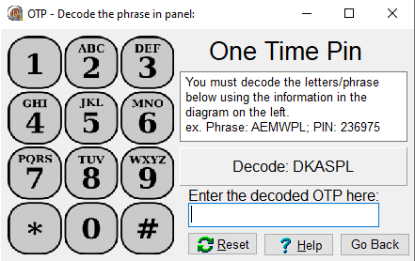

|  |  |
| --- | --- |
| **Components** | |
| **Component** | **Description** |
| Labels | A Label will be used for the heading ‘One Time Pin’.  It will also be used to describe what the user should type in the edit box |
| Image | The image component will be used to give the decoding information to the user. |
| Rich Edit | A rich edit will be used to show a short description of what the user should do. The help button gives more information, because there isn’t enough space in the rich edit to explain everything. |
| Panel | The computer will display the code that the user must decode in the panel. |
| Edit Box | The user should enter the decoded OTP in this edit box. Every time the user enters a key, it will test if it is the correct PIN. If it is too long, it will give an error message. If it isn’t the correct pin, a message will be displayed. |
| Button – Go Back | When the Go Back button is clicked, the user can reselect the method they want to use as multifactor authentication. It will take them back to Panel 1 of the 2nd form. |
| Bitmap button - Reset | If the user wants to regenerate the captcha, they can click here. This bitmap button is kind ‘Retry’. |
| Bitmap button - Help | The “help” button is a bitmap button with kind ‘Help’. It gives us more information about how the program works, and how to use the program when it is clicked by the user. |

## Form 2 – Panel 3: Text Captcha

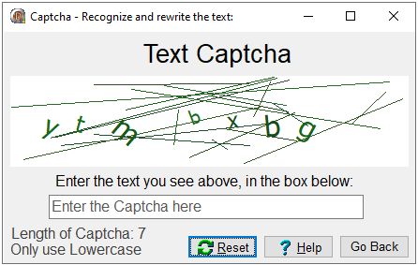

|  |  |
| --- | --- |
| **Components** | |
| **Component** | **Description** |
| Labels | A Label is used for the heading ‘Text Captcha’.  It is also used to describe what the user should type in the edit box.  On the bottom left of the form, labels will be used to tell the user what letters they should type (capital letters or lowercase letters, and the length of the Captcha) |
| Image | The image component and its canvas property will be used to create a unique captcha every time. The captcha will be displayed in this component |
| Edit Box | The user should enter the Captcha in this edit box. Every time the user enters a key, it will test if it is the correct Captcha. If it is too long, it will give an error message. If it isn’t the correct captcha, a message will be displayed. |
| Bitmap button - Reset | If the user wants to regenerate the captcha, they can click here. This bitmap button is kind ‘Retry’. |
| Button – Go back | When the Go Back button is clicked, the user can reselect the method they want to use as multifactor authentication. It will take them back to Panel 1 of the 2nd form. |
| Bitmap button - Help | The “help” button is a bitmap button with kind ‘Help’. It gives us more information about how the program works, and how to use the program when it is clicked by the user. |

## Form 3 – Panel 1: Used by Learners

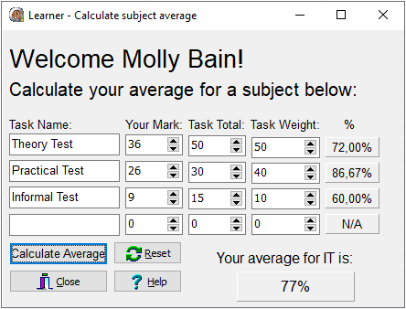

|  |  |
| --- | --- |
| **Components** | |
| **Component** | **Description** |
| Labels | A Label will be used for the heading ‘Welcome <Name> <Surname>!’ and subheading ‘Calculate your average for a subject below:’  It will also be used to describe what the user should type in the edit boxes.  On the bottom right of the form, a label will be used to show the user the subject, and below it the average for that subject will be displayed (in the Panel). |
| Panels | The average for the subject will be shown in this panel.  Panels are also used to show the percentage the user has for every task. |
| Edit Boxes | The user will use edit boxes to enter the names of the Tasks. |
| Spin Edits | The spin edits will be the primary components that the user will use to enter more information about the task. They are used to enter the user’s mark, the task total, and the weight of the task. |
| Button – Calculate Average | When the user clicks this button, it will use a formula to calculate the user’s average for this subject. |
| Bitmap button - Close | When the Close button is clicked, the log file will be closed, and then the program will be closed |
| Bitmap button - Reset | If the user wants to reset all the components on this panel, they can click here. This bitmap button is kind ‘Retry’. |
| Bitmap button - Help | The “help” button is a bitmap button with kind ‘Help’. It gives us more information about how the program works, and how to use the program when it is clicked by the user |

## Form 3 – Panel 2: Used by Teachers

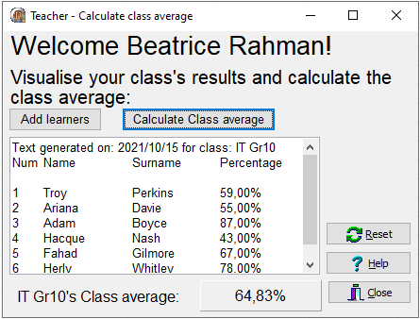

|  |  |
| --- | --- |
| **Components** | |
| **Component** | **Description** |
| Labels | A Label will be used for the heading ‘Welcome <Name> <Surname>!’ and subheading ‘Visualise your class’s results and calculate the class average’  On the bottom left of the form, a label will be used to show the class name, and next to it the average of that class will be displayed (in the Panel). |
| Button – Add learners | When the user clicks this button, it will allow the user to enter the names, surnames and percentages of users using input boxes. This information will then be displayed in the rich edit. |
| Button – Calculate class average | This button will use a formula to calculate and display the class’s average in the label and panel. |
| Rich Edit | A rich edit will be used to show the information about the learners. The user will enter this information using input boxes. |
| Panel | The class average will be shown in this panel. |
| Bitmap button - Close | When the Close button is clicked, the log file will be closed, and then the program will be closed |
| Bitmap button - Reset | If the user wants to reset all the components on this panel, they can click here. This bitmap button is kind ‘Retry’. |
| Bitmap button - Help | The “help” button is a bitmap button with kind ‘Help’. It gives us more information about how the program works, and how to use the program when it is clicked by the user |

## Form 3 – Panel 3: Displayed to Admins

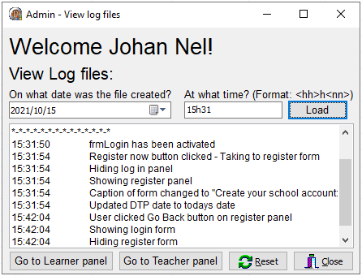

|  |  |
| --- | --- |
| **Components** | |
| **Component** | **Description** |
| Labels | A Label will be used for the heading ‘Welcome <Name> <Surname>!’ and subheading ‘View Log files:’  It will also be used to describe what the user should type in the edit box, and what the Date Time picker is for. |
| Date Time Picker | The user will use the Date time picker to tell the system on what date the Log file has been created. |
| Edit Boxes | The user will use the edit box to enter time. This time will be the time that the log file was created. |
| Button – Load | When the user clicks this button, the system will generate the file name, test if the file exists and then load the file in the Rich Edit |
| Rich Edit | A rich edit to display the loaded log file. (As described above) |
| Button – Go to Learner panel | This button will take the admin to the Learner panel if they need to test something there. When the admin clicks this button, a back button will be displayed on the form they go to. |
| Button – Go to Teacher panel | This button will take the admin to the Teacher panel if they need to test something there. When the admin clicks this button, a back button will be displayed on the form they go to. |
| Bitmap button - Close | When the Close button is clicked, the log file will be closed, and then the program will be closed |
| Bitmap button - Reset | If the admin wants to reset all the components on this panel, they can click here. This bitmap button is kind ‘Retry’. |
| **Note:** There is no help button on this panel since the admin should already know everything. They do not need help to use their system… | |

# Data dictionary

I have looked into using text files to store information about users, such as their usernames and passwords. It seemed far too complicated to use one text file to store this information. Therefore, I decided that I will be using a simple database to store information about the user. I will base my database design on a tutorial my Mr. Long, which can be found [here](https://www.youtube.com/watch?v=RIv0XFQJaM8&list=PLxAS51iVMjv8Xl1FfV9GQ2dwhqttUrAT6&index=10).

After some consideration, I will be using text files to store the information the ‘Help’ bitmap buttons should display. These text files will be stored in the program folder and will be used as output when the button is clicked.

Text files will also be used as ‘log’ files. These files will store everything the user does so that the admin can investigate it if something went wrong. Once again, some code for this will be based on a tutorial my Mr. Long, which can be found [here](https://www.youtube.com/watch?v=bUpSl3fvPNs). The Captcha will also be stored as a .png file (if the user chose the Captcha), so that the admin can investigate it if something went wrong.

# Extra information

## Premade users in the Database

I have already created a user profile for every user type. There is Molly Bain as a learner, Beatrice Rahman as a teacher, and Johan Nel as an admin.

Instead of creating a new user for every user type, you can use these (if you want to, otherwise, feel free to create your own).

**Please note:** The learner and teacher profile were created randomly. I used a name and surname generator for the names and surnames and a date generator for the birthdates. The passwords are average, and shouldn’t be used in the real world.

Information about the users:

|  |  |  |  |  |  |
| --- | --- | --- | --- | --- | --- |
| UserLoginN.mdb: 2002-2003 Format | | | | | |
| Username | **Password** | **First_Name** | **Last_Name** | **Birth_Date** | **User_Type** |
| MolL2006ain | BalinB@123! | Molly | Bain | 2006/12/09 | L |
| BeaT1985man | Rahman@Nod!1 | Beatrice | Rahman | 1985/02/24 | T |
| JohA2005Nel | H3llo@World! | Johan | Nel | 2005/11/23 | A |

## Captcha generator links

I used these websites to help me create the text captcha using the canvas property of an image component:

* [Common Properties and Methods of Canvas](https://docwiki.embarcadero.com/RADStudio/Sydney/en/Common_Properties_and_Methods_of_Canvas)
* [How to draw text with different font formatting to a canvas in Delphi at once?](https://stackoverflow.com/questions/16061328/how-to-draw-text-with-different-font-formatting-to-a-canvas-in-delphi-at-once)
* [Using canvases for Drawing](https://docwiki.embarcadero.com/RADStudio/Sydney/en/Using_Canvases_for_Drawing)
* [Using the properties of the Canvas object](https://www.delphipower.xyz/guide_3/using_the_properties_of_the_canvas_object.html)

## Enable the Database in the Delphi program

How to enable the database on a new computer: These steps should *only* be done if the program crashes when registering an account/log in. You *should* only have to do the steps once per computer.

1. Open dmUserLogin_u in the frmLogin_p file manager in the top right (doubleclick)  
   Graphical user interface, application, Word

   Description automatically generated
2. Click on dmUserLogin_u at the top (go to dmUserLogin_u)  
   Graphical user interface, text, application, Word

   Description automatically generated
3. Click on ConUserDatabase  
   A picture containing diagram

   Description automatically generated
4. In the ConnectionString property of ConUserDatabase, click on the three dots next to the text field  
   Graphical user interface, text, application, email

   Description automatically generated
5. Select 'Use connection string', and click on build  
   Graphical user interface, text, application, email

   Description automatically generated
6. Click on the three dots next to the 'Select or enter a database name’ edit box.  
   Graphical user interface, text, application, email

   Description automatically generated
7. Click on UserLogin.mdp and click open  
   Graphical user interface, application, table

   Description automatically generated
8. When done, click test connection to make sure the connection was succesful, and close the two popup menus.  
   Graphical user interface, text, application, email

   Description automatically generatedGraphical user interface, text, application

   Description automatically generated  
   Graphical user interface, text, application, email

   Description automatically generatedGraphical user interface, text, application

   Description automatically generated
9. Click on tblData, and in its Active property, make sure that it is activated (Active Property = True).  
   A picture containing diagram

   Description automatically generated  
   Graphical user interface, application

   Description automatically generated